Flutter installation document:-

Step 1 : - download sdk

Dart sdk : <https://dart.dev/get-dart/archive>

Flutter sdk: <https://docs.flutter.dev/release/archive>

IDE Vs code : <https://code.visualstudio.com/download>

Step 2: vs code extensions = flutter+ dart (install)

Step 3: SEARCH

ENVIRONMENT VARIABLE

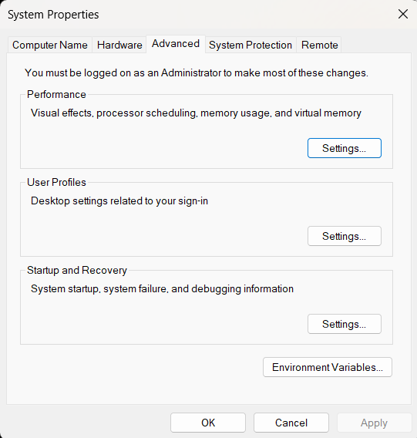

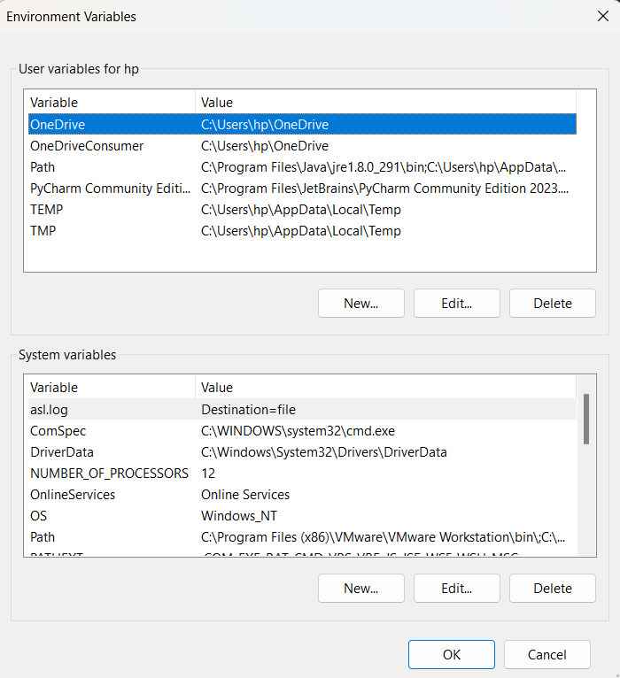

CLICK PATH IN SECOND TABLE COLUMN

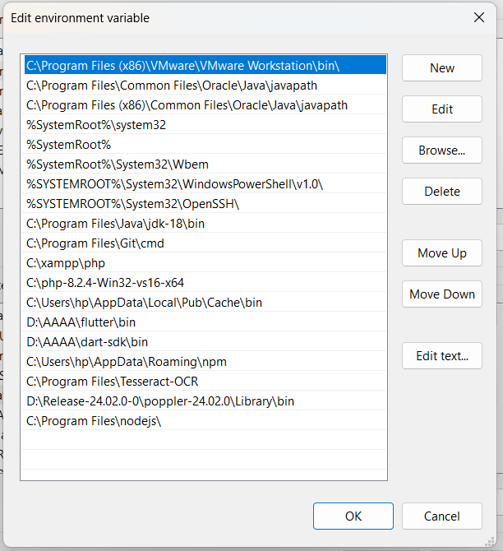

ADD PATH

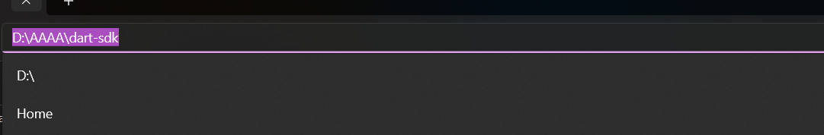

DONE!

CHECK BY = CTRL + SHIFT +P ( SEARCH = FLUTTER)